**JMeter Understanding Document::**

<https://www.blazemeter.com/blog/ibm-mq-testing-with-jmeter-learn-how>

1. Start JMeter
2. Create a Test Plan
3. Create a Thread Group ( users)
4. Add a Sampler (Http)
5. Add Listeners ( View Results Tree, View Results in Table )
6. To run the test

Clear: Clear result from specific listener.

Clear All : Clear everything from every result listener.

26/08/2020

**after recording, Change Recording controller to Transaction controller**

use 8181 port for recording and remove the port after recording.

#################################### Assertions ################################

**Assertion:** Check on the response

1. Response Assertion

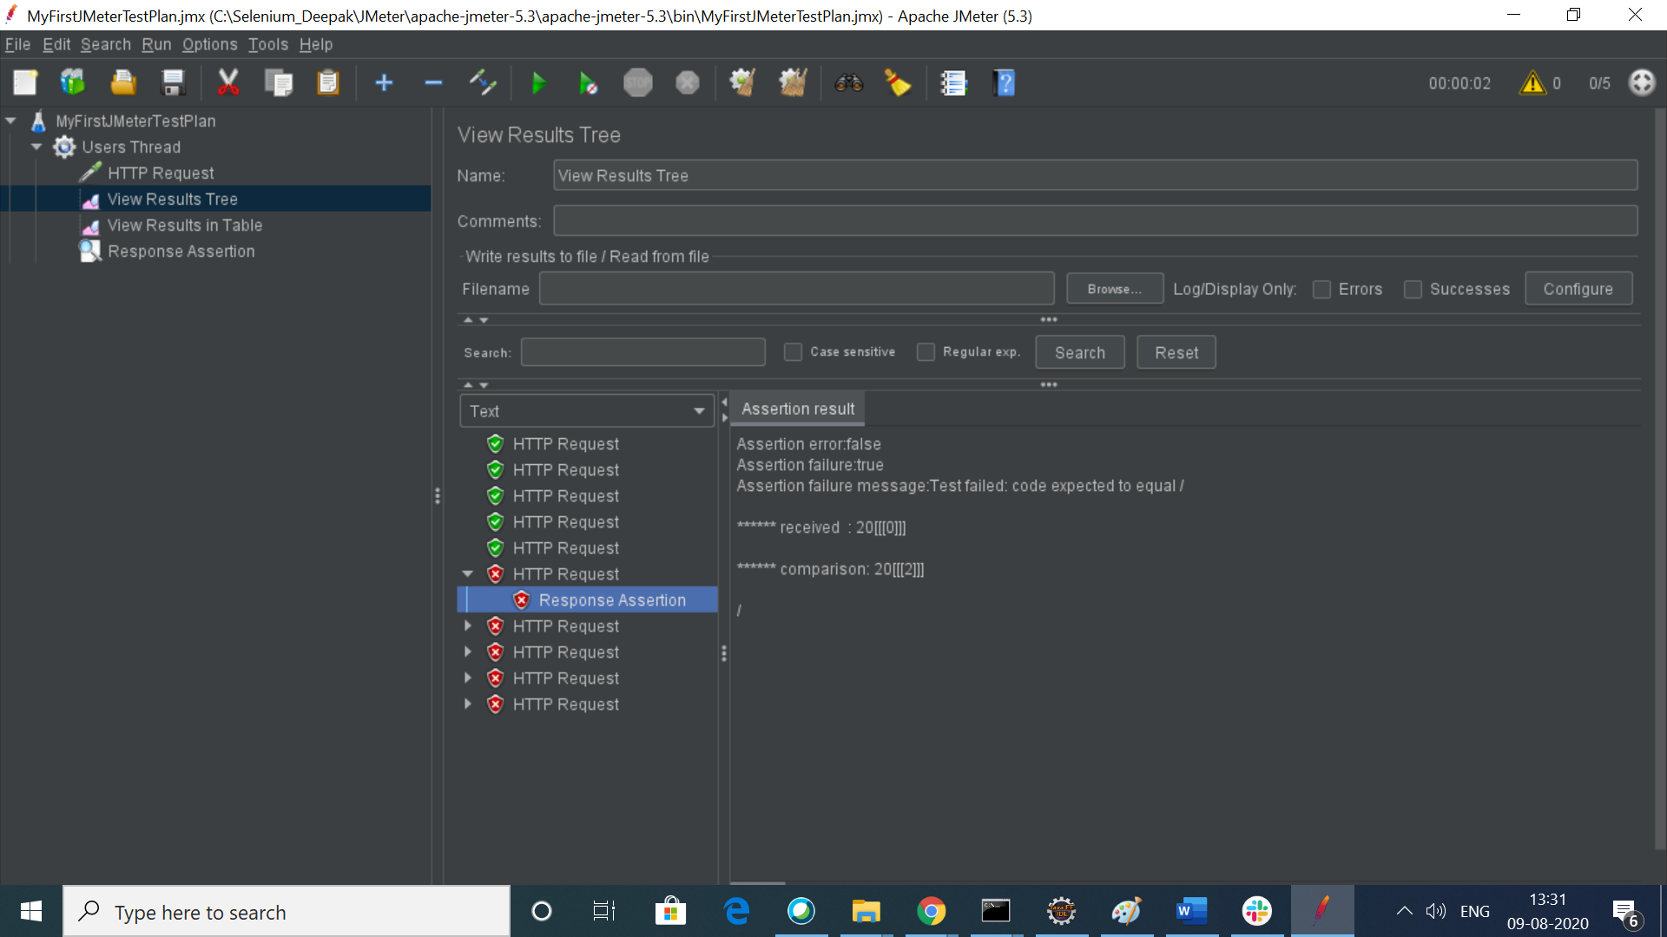

1. Duration Assertion
2. Size Assertion:

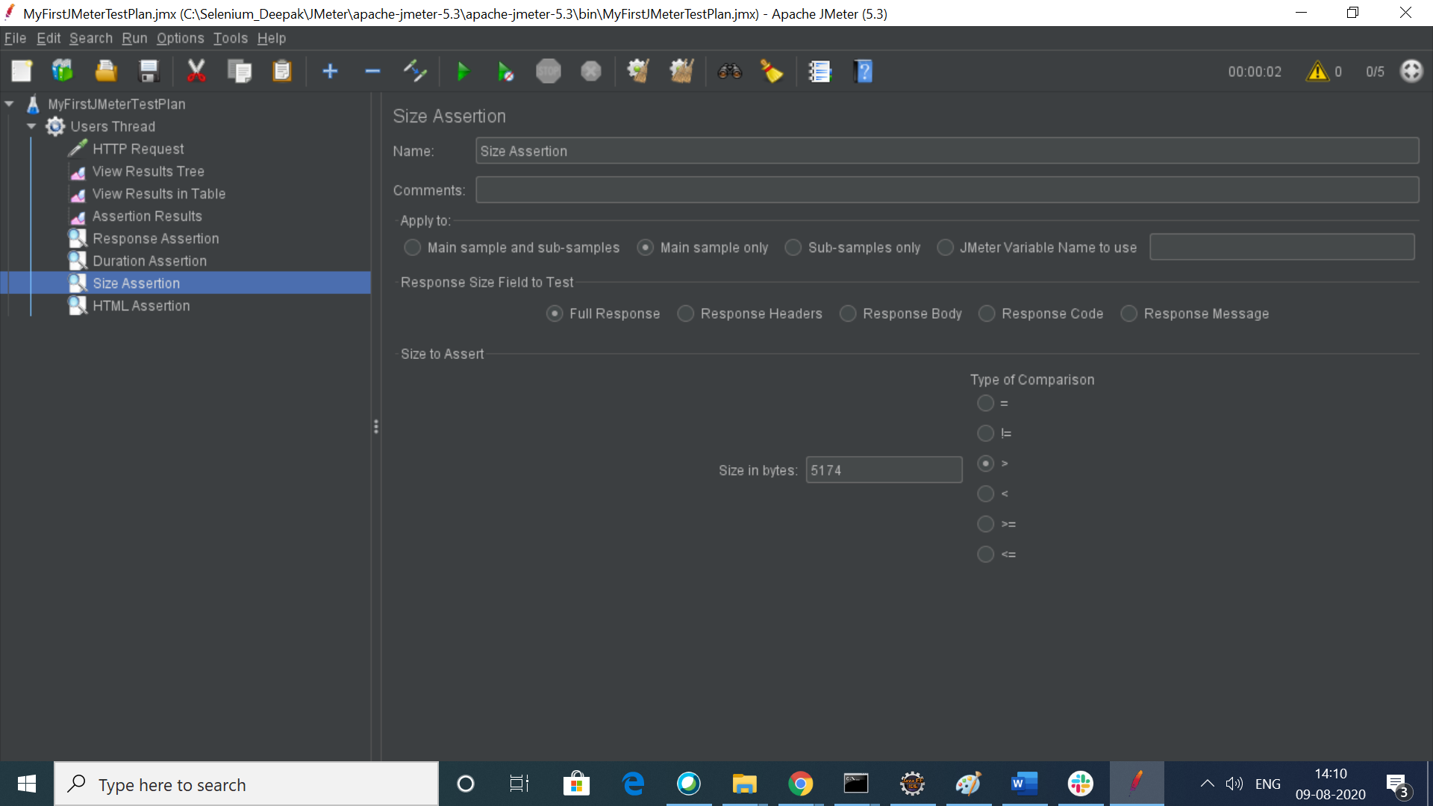

1. HTML Assertion ::

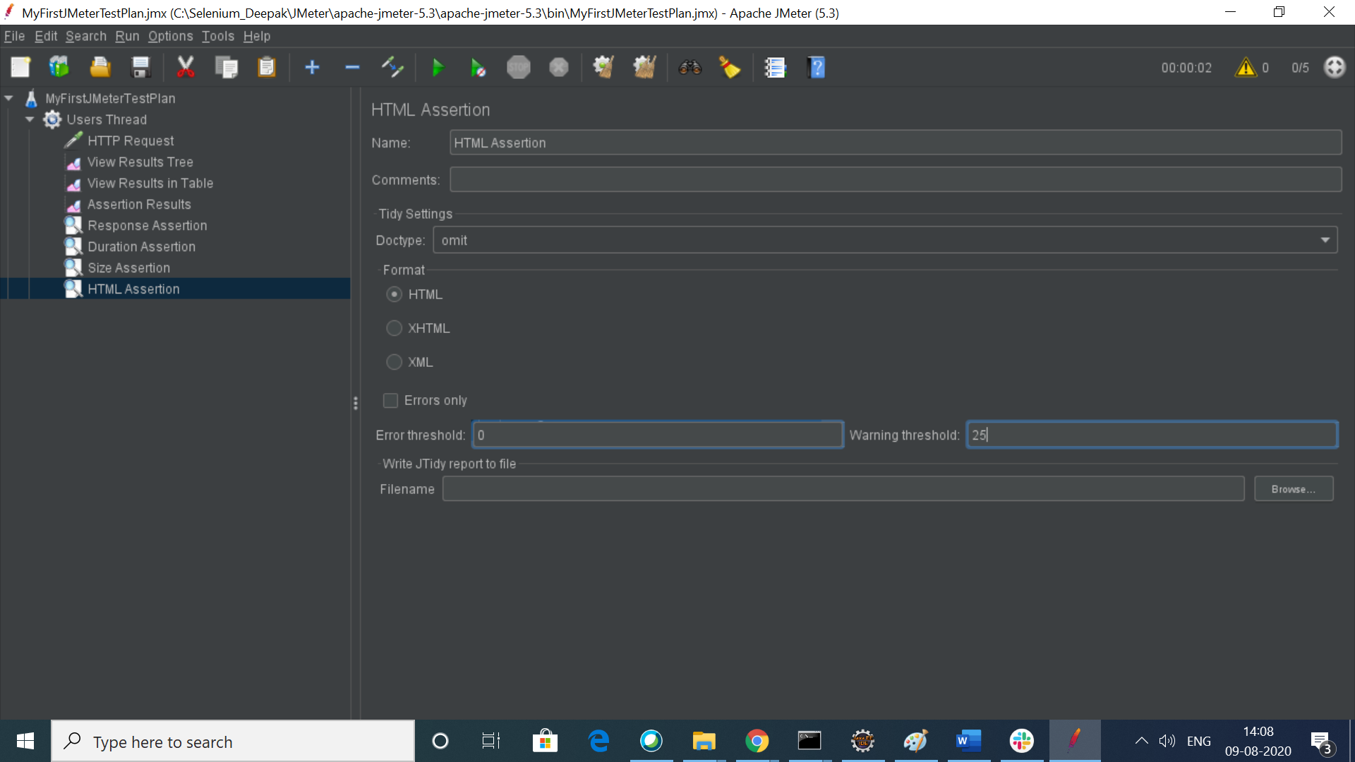

1. XML Assertion

############################################# Listener ############################

Listener : Display the result of performance test

**Listeners** are the **JMeter** component that displays test results.

All Listeners can be found by clicking Add->Listeners.

Latency: Time to first byte

1. View Results in Table ::

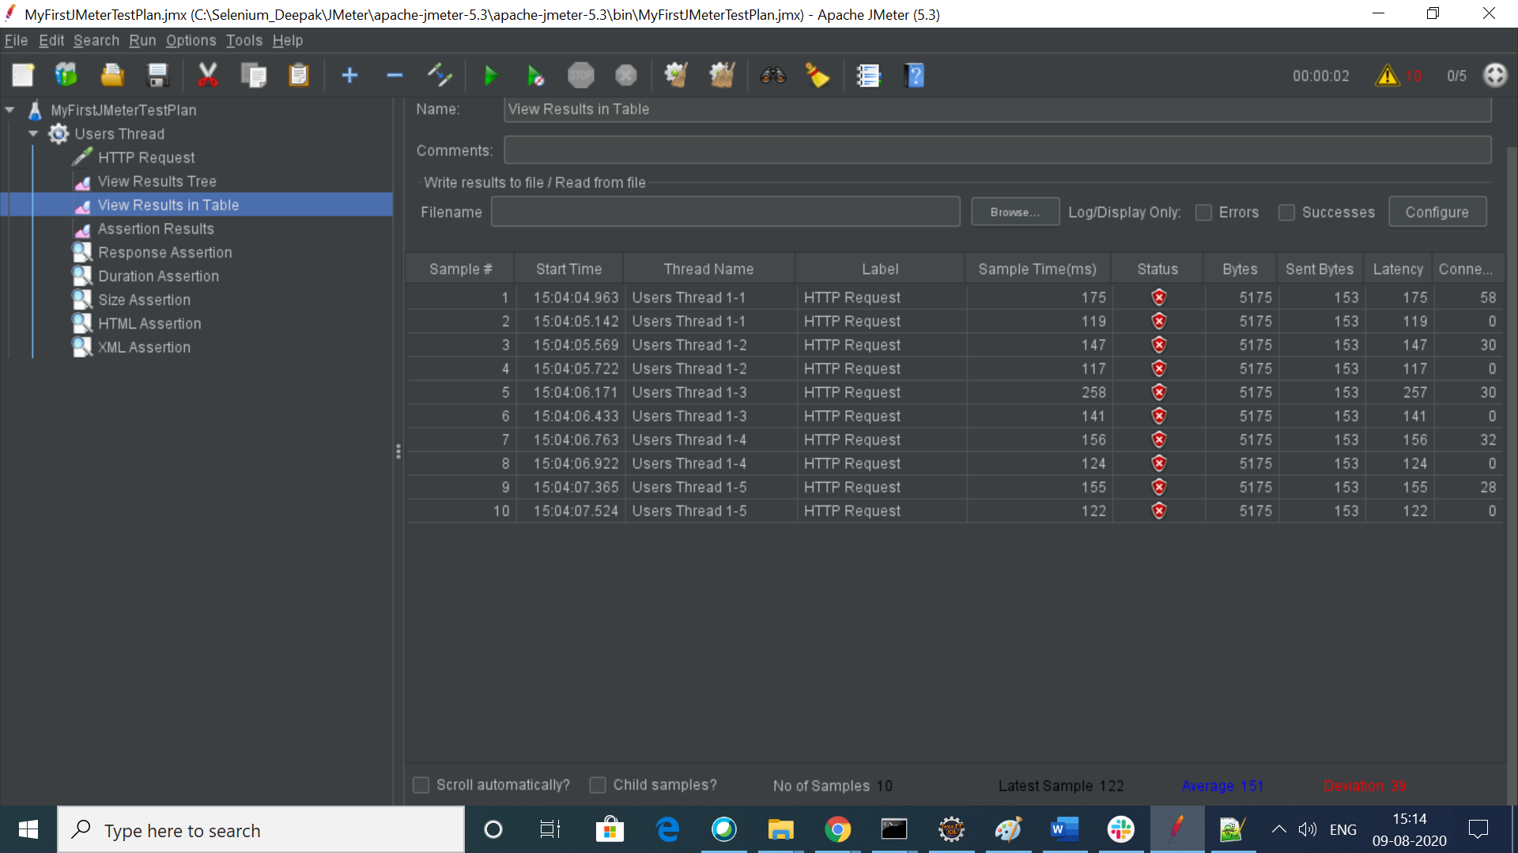

1. View Results tree : Try to avoid using it in case of heavy performance loas as it take much memory.
2. Assertion Result.
3. Aggregate Report
4. Summary Report
5. Simple Date Writer

Function :

$(_time()}

############################# How to set proxy in firefox ######################

Link : <https://www.youtube.com/watch?v=1cRI8-JWQho>

In Firefox, Open to Firefox and then click on Settings.

Search proxy

Clixk on settings then select Manual proxy Configuration

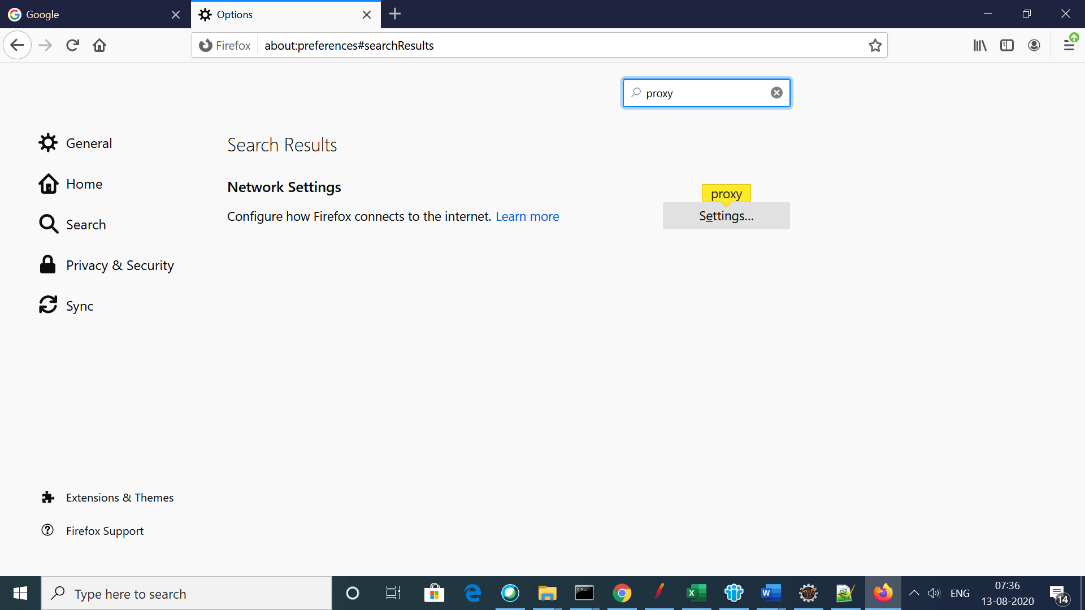

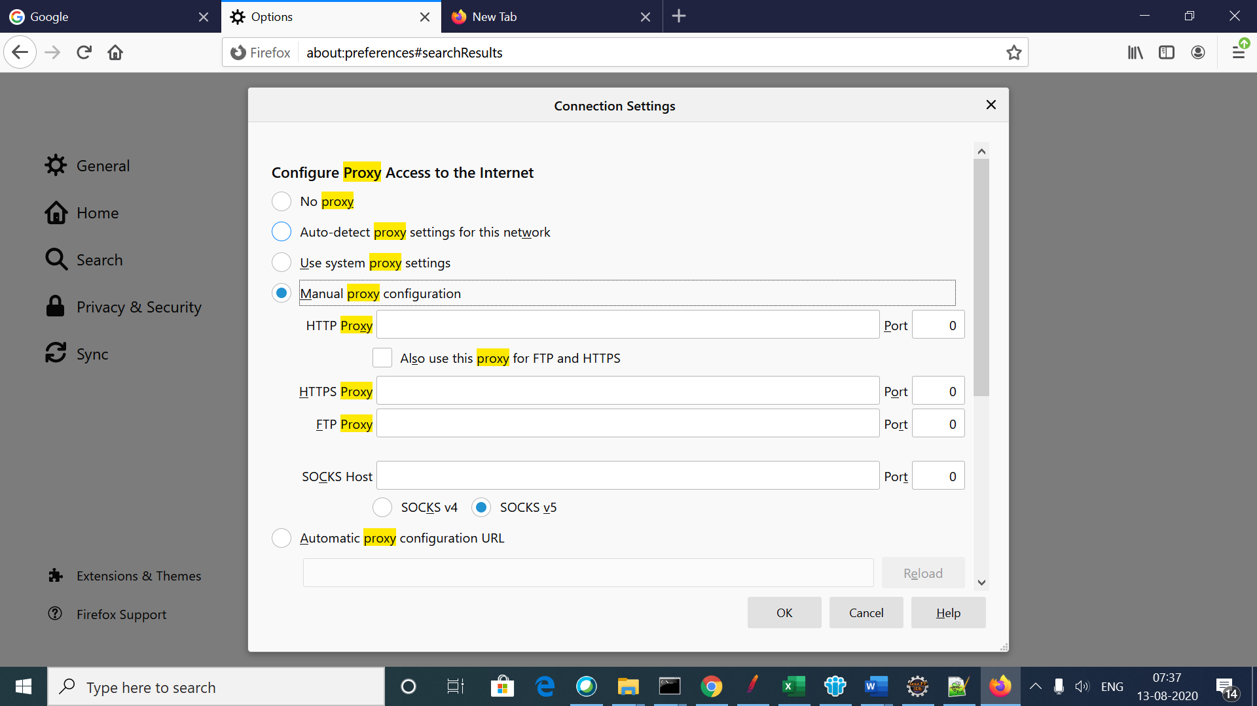

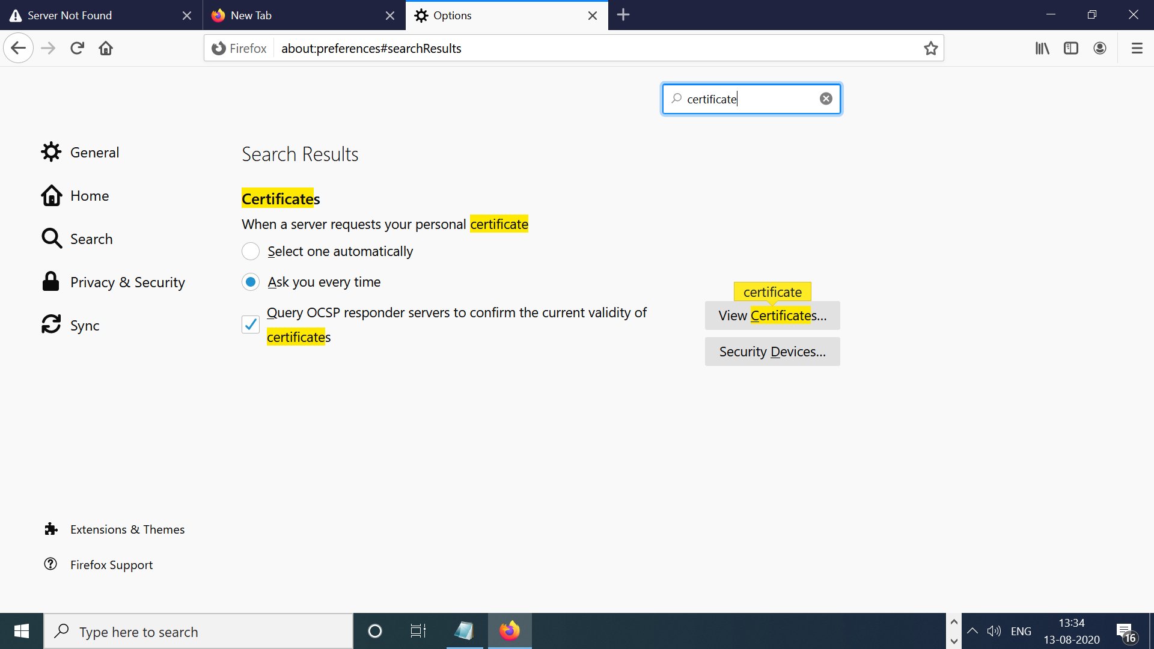

Click on Import and select certificate from bin folder

